CREATING PRIVATE BUCKET IN S3
STEP 1:
In your AWS management console ,after signing in you will see all the services provided by them. Use the S3 service for creating bucket. Click on ‘Create bucket’

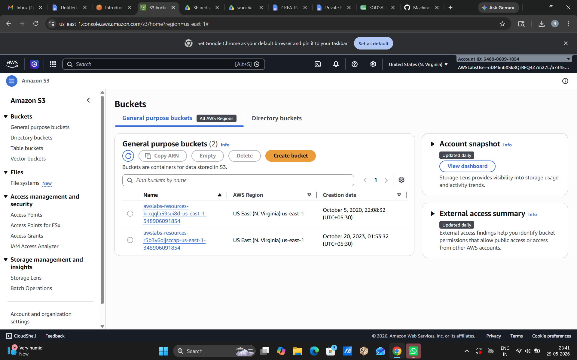

STEP 2:
ACL stands for access control list. After clicking on ‘create bucket’ you are only suppose to configure the required settings. Use a unique name for your bucket and select a region . For a private bucket use the following settings shows in the screen shot. After that click on ‘Create bucket’ and your bucket would be created.
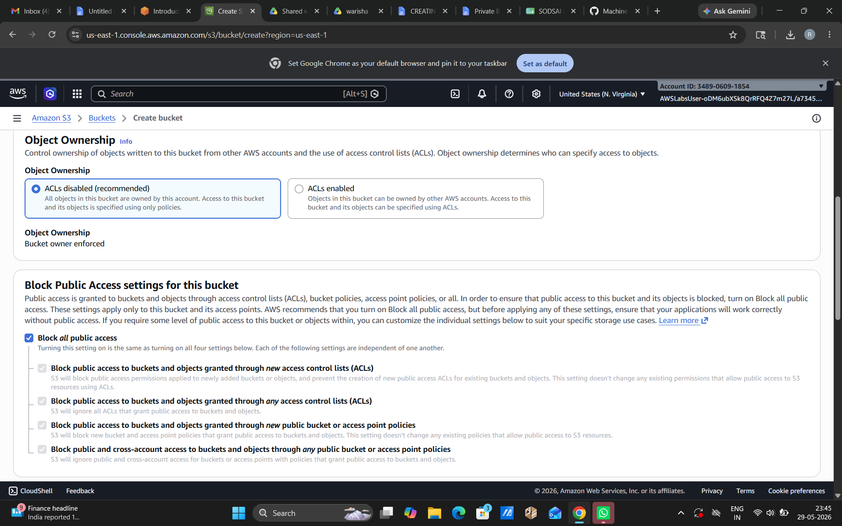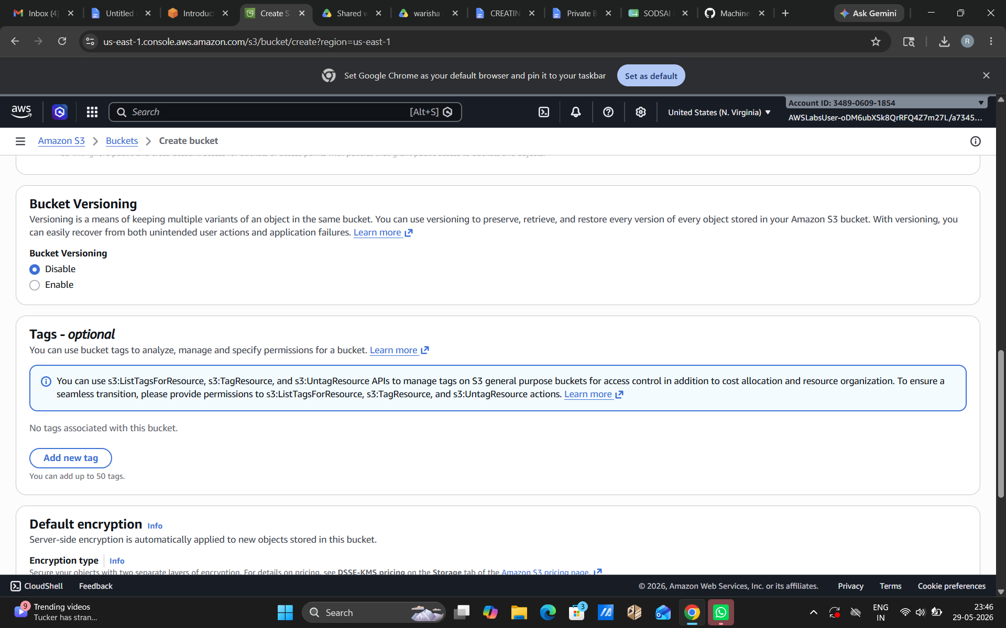

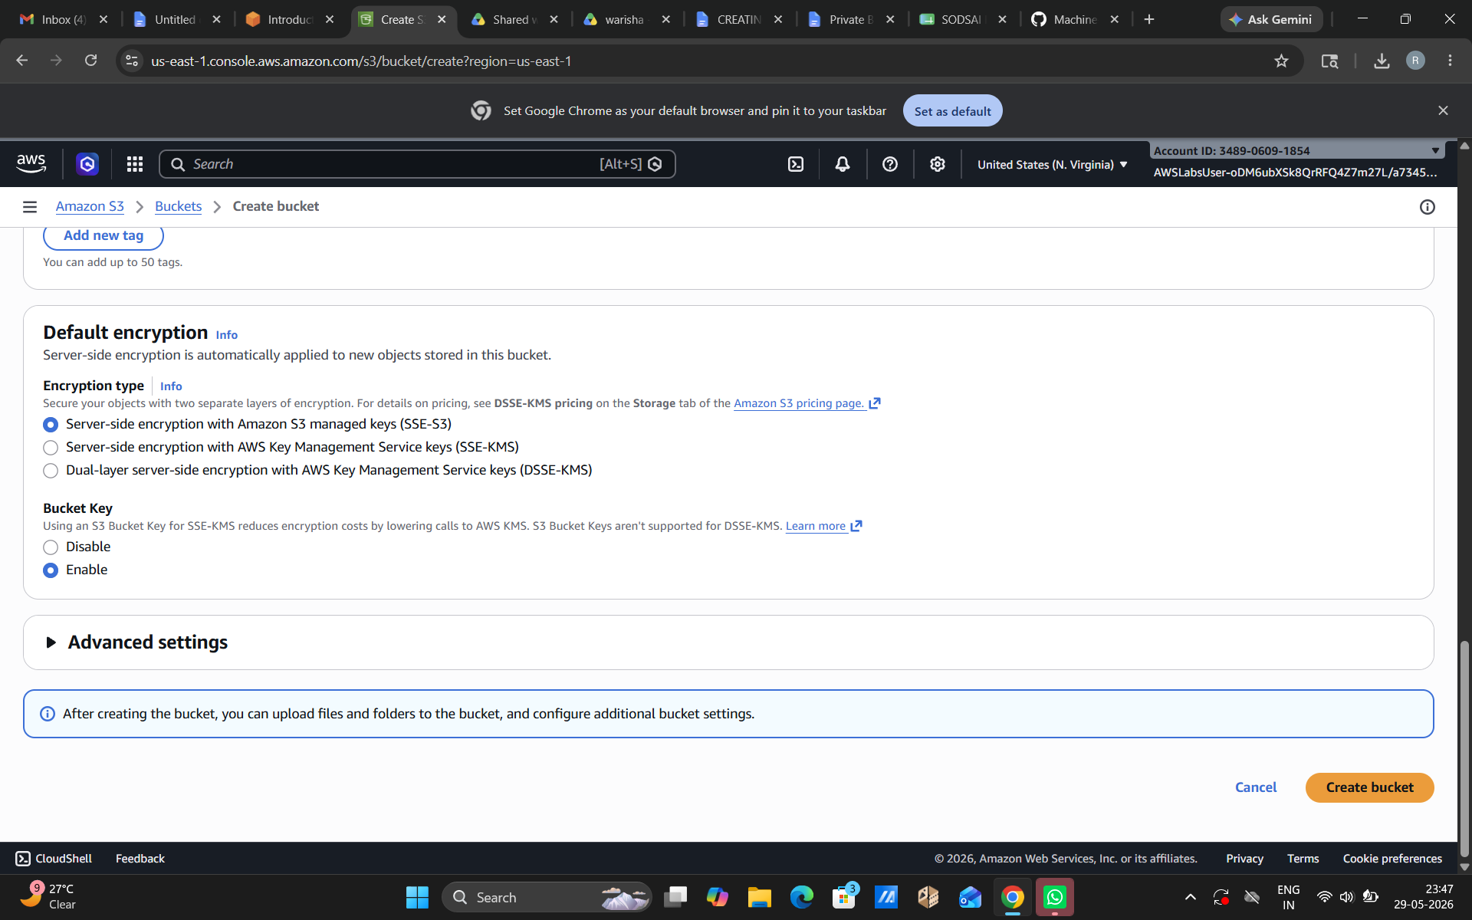

STEP 3:
After creating the bucket open the bucket in amazon S3. The page in front of you would be the bucket’s dashboard, where you can view and manage files and edit the permission and settings of the bucket.

